What is Google My Business?

[My Business](https://www.google.com/business/) is Google’s one-stop shop to manage how your business will look and perform in the search engine. It is an essential tool to find out and adjust how your site shows in Maps, the Knowledge Graph, Google+ and organic search results. According to the 2017 edition of [Moz’ Local Search Ranking Factors Survey](https://moz.com/blog/local-search-ranking-factors-survey-results-2017), Google My Business continues to be the biggest driver of local SEO success, with quality links coming in at a close second.

You can manage your business listing by adding NAP details, opening hours, photos et cetera. In addition to that, it is possible to manage the reviews your customers leave behind. As you know, reviews should be a key factor in your [local SEO efforts](https://yoast.com/tips-local-seo-content-strategy/).

How does it work?

Getting started with My Business is easy; you have to make an account and claim your business. After filling in your details, you will get a real-life postcard from Google on the address you’ve specified. This card is the only proof you’re the owner of the business listed at the address.

Once verified, you can fill in all the necessary details and check how your listing is doing. You can even get regular insights to see how many impressions, clicks and subscribers your listing got over a period. It’s a great way of getting a feel for how your business is perceived by Google and customers alike.

Keep in mind that My Business is not the catch-all tool for your local SEO. It has to work in tandem with your on- and off-site SEO efforts. You won’t climb the charts if your profile is inaccurate, but you also won’t reach the top without a well-optimized site and localized content. These things go hand in hand.

Ranking factors

Google My Business uses many [factors to determine rankings](https://yoast.com/seo-local-ranking-factors/) for businesses. We’ll highlight the three most important ones:

* Relevance
* Distance
* Prominence

Relevance

Relevance determines how well your business fits the search intent of the customer. Is your focus identical to what the customer needs or are you a bit opaque about what your business does? Vagueness doesn’t rank. Be as clear as you can be. Keep your focus.

Distance

Distance is a well-known factor for ranking local businesses. You can’t rank in a local search for (dentist New Jersey) when you have located your company in Manhattan. The exact way Google determines which businesses to show in a local search is unknown, and it can be pretty hard to rank in a given area. The other factors play a significant role as well. It helps not just to say you are located in a particular area, but also to show it by creating local-oriented content around your business on your site. Google uses what’s known about the location of the searcher to present the most relevant local businesses.

Prominence

Prominence is all about the activity around your listing; this could be the number of reviews, events, local content et cetera. It also helps if you can get loads of [quality links](https://yoast.com/successful-linkbuilding-strategy/) to your site. It is somewhat hard to determine what prominence means exactly, but one thing is sure: no one likes dead profiles. You have to keep it updated with new photos and manage your reviews. As said before, this works in tandem with your site, so make sure both listings align and that you publish local content.

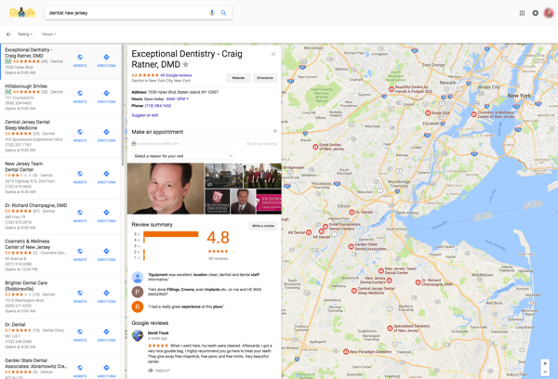

Optimize your Google My Business listing

To start, you need to claim your listing. After that, you can use the following tips to make your My Business account a success. Keep in mind that everything you add must be in line with the information you provide on your site. Inaccurate information kills your listings and could kill your rankings:

* Claim your listing with your actual business name
* Choose a category as accurate as possible
* Provide as much data as you can – your profile has to be 100%
* Check your phone number
* Check your opening times – think about holidays!
* Review your photos – are they accurate and good or can you improve them?
* Create citations on other sites as well – pick well-regarded business listing or review sites and directories, stay away from spammers
* Keep your My Business listing in line with your site – and use Schema.org data
* Above all, keep your data up to date

It’s critical to remember that this is not a set it and forget it type of thing. Things change, your business changes. Keep everything active, [monitor reviews](https://yoast.com/get-local-reviews-ratings/) and stay on top of things. It’s frustrating if your listing doesn’t perform as well as you’d like, but keep putting in the hours, and it will work. US businesses can check their listings with this tool by Synup: [Google My Business Guidelines Checker](https://synup.com/tools/google-checker/).

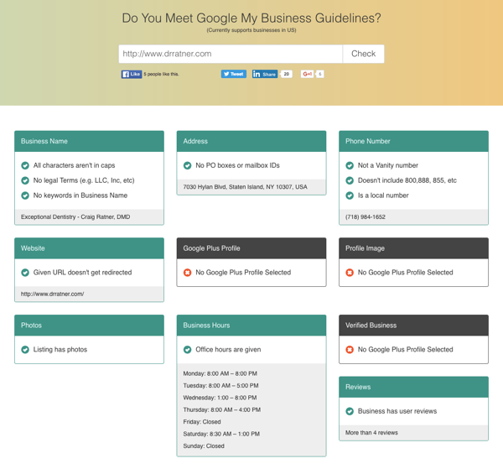

Structured data and Yoast Local SEO

Google increasingly depends on [structured data](https://yoast.com/structured-data-schema-ultimate-guide/) to find out what your site is about and which elements represent what. This is most certainly true for your business information, including the information that My Business uses. Make sure you add the correct structured data to your site. [Enhance your NAP details](https://yoast.com/local-business-listings/), opening hours, [reviews](https://yoast.com/grow-your-business-with-ratings-and-reviews/), [product information](https://yoast.com/rich-snippets-product-listings/) et cetera, with Schema.org data. This will make it much easier for Google to determine the validity of your listing. Several tools can help you with this, including our [Yoast Local SEO plugin](https://yoast.com/wordpress/plugins/local-seo/).

Your local SEO is critical, even with Google My Business

So, you should activate and maintain your My Business account, and make it awesome. But to get the most out your listings and to get good rankings, you must have your site in order as well. Optimize every part of it. Create local content for your chosen keyword and business location. Acquire quality local backlinks to build up a solid link profile. Ask customers to review your business onsite or on My Business. Make sure your listing is active and attractive. Dead profiles are no good.